Name: ........................................................ Class / Stream: ............. Sign: ...................

**……/1**

CHEMISTRY

**PAPER 1**

APRIL-2024

**……. H**RS

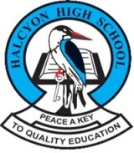

**HALCYON HIGH SCHOOL**

**U.C.E PRE-MOCK EXAMINATIONS –2024**

**CHEMISTRY**

Paper 1

**TIME:2 HOURS**

**INSTRUCTIONS:**

*Attempt* ***all*** *Items.*

**SECTION A**

**Attempt all items in this section**.

**ITEM ONE**

In one of the towns in Uganda, residents are facing an unexpected challenge of water wasting soap. The locals are frustrated, do not understand the cause and what to do. However, they have heard of other detergents on market that work better but they need more advice on this.

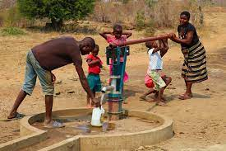 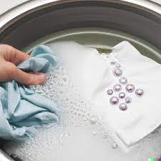

A resident has sought your assistance, confident that you can use your knowledge of chemistry to provide help

**TASK**

1. (i) Explain the category of the products.

…………………………………………………………………………………..

……………………………………………………………………………………

……………………………………………………………………………………

(ii) Help the locals understand how the product works.

…………………………………………………………………………………

……………………………………………………………………………………

…………………………………………………………………………………..

……………………………………………………………………………………

……………………………………………………………………………………

1

1. (i) Advice the locals on the Challenges associated with the long term use of the product.

……………………………………………………………………………………

……………………………………………………………………………………

……………………………………………………………………………………

……………………………………………………………………………………

……………………………………………………………………………………

……………………………………………………………………………………

……………………………………………………………………………………

(ii) Guide the locals on the evaluation of both products.

……………………………………………………………………………………

……………………………………………………………………………………

……………………………………………………………………………………

……………………………………………………………………………………

……………………………………………………………………………………

……………………………………………………………………………………

……………………………………………………………………………………

……………………………………………………………………………………

…………………………………………………………………………………….

2

2. Patrick a student at halcyon high school is a plastic collector, he also collects damaged jerrycans, buckets, plastic bottles etc. He also sells the collected plastic bottle and bags to the recycling industries from which he also attains income for his survival.

**Support material.**

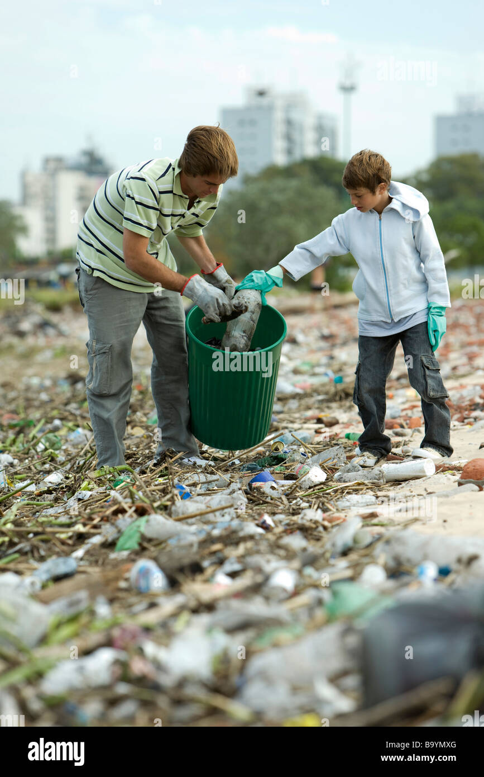

**TASK**

1. (i) Guide Patrick on the category of the materials.

……………………………………………………………………………………

……………………………………………………………………………………

……………………………………………………………………………………

……………………………………………………………………………………

……………………………………………………………………………………

……………………………………………………………………………………

3

(ii) Help Patrick know how important he is to the environment.

……………………………………………………………………………………

……………………………………………………………………………………

……………………………………………………………………………………

……………………………………………………………………………………

……………………………………………………………………………………

……………………………………………………………………………………

(b) As an official from NEMA. Write brief Notes to be presented to the public in village meetings including other ways of protecting the environment from harmful effects of polymers.

……………………………………………………………………………………

……………………………………………………………………………………

……………………………………………………………………………………

……………………………………………………………………………………

……………………………………………………………………………………

……………………………………………………………………………………

……………………………………………………………………………………

……………………………………………………………………………………

……………………………………………………………………………………

……………………………………………………………………………………

……………………………………………………………………………………

……………………………………………………………………………………

4

**SECTION B**

Attempt all items

**Item 3**

Many people in villages make a living by manufacturing local waragi (ethanol).

However, the government is against the business due to associated challenger. .The district LC5 chairperson wants to sensitize the community about the large scale production process and its impact to enable them understands the government position.

**Support material.**

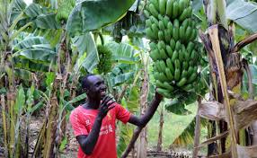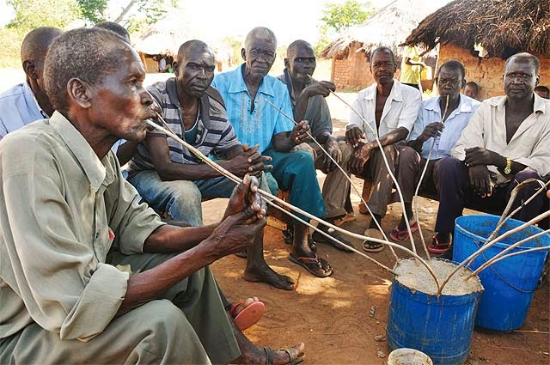\

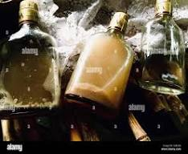

The district LC5 chairperson has contacted you as a student with the knowledge of chemistry in your village to provide the relevant information.

**TASK**

Make a write up to use upon meeting the community.

6

**ITEM 4**

Evaporation, condensation, transpiration and precipitation are physical process that lead to the formation of droplets of a colorless liquid seen on grass very early in the morning. The liquid is very useful in day life. When a student added anhydrous Copper (II) Sulphate to a drop of a liquid the white solid turned blue.

The student wondered what the liquid could have been.

**Support material**

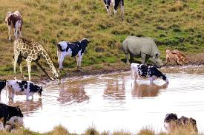

Variety of animals are taking water and some urinating and defecating on the water.

The student contacted you as a halcyon student with the knowledge of chemistry to guide him/her and relevant information about how the liquid.

**Task**

Guide your fellow learner.

**END**